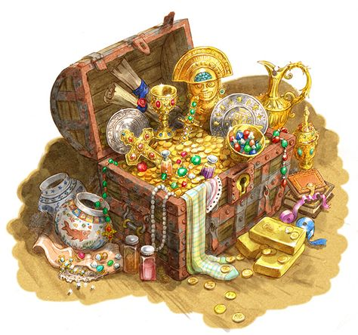

***Valuable Baubles***

Treasure, Art and Gem prices taken straight from the 5E DMG and sorted for ease.

### Random Treasure

#### ***25 GP***

*Black velvet mask stitched with silver thread - 25 GP*

*Carved bone statuette - 25 GP*

*Copper Chalice with silver filigree - 25 GP*

*Cloth-of-gold vestments - 25 GP*

*Embroidered silk handkerchief - 25 GP*

*Engraved bone dice - 25 GP*

*Gold locket with painted portrait inside - 25 GP*

*Silver ewer - 25 GP*

*Small gold bracelet - 25 GP*

*Small mirror set in painted wooden frame - 25 GP*

#### ***250 GP***

*Box of turquoise animal figurines - 250 GP*

*Brass mug with jade inlay - 250 GP*

*Carved ivory statuette - 250 GP*

*Gold bird cage with electrum filigree - 250 GP*

*Gold ring set with bloodstones - 250 GP*

*Large gold bracelet - 250 GP*

*Large well-made tapestry - 250 GP*

*Silk robe with gold embroidery - 250 GP*

*Silver necklace with a gemstone - 250 GP*

#### ***750 GP***

*Carved obsidian statuette with gold fittings - 750 GP*

*Electrum dagger with black pearl in pommel - 750 GP*

*Gold dragon comb set with gems as eyes - 750 GP*

*Harp of exotic wood with ivory inlay and gems - 750 GP*

*Painted gold war mask - 750 GP*

*Silver chalice set with moonstones - 750 GP*

*Silver and gold brooch - 750 GP*

*Silver-plated Longsword with a gem set in hilt - 750 GP*

*Small gold idol - 750 GP*

*Wine cork embossed with gold leaf and gems - 750 GP*

#### ***2,500 GP***

*Embroidered gloves with jewel chips - 2,500 GP*

*Gold music box - 2,500 GP*

*Jeweled anklet - 2,500 GP*

*Necklace of stringed pink pearls - 2,500 GP*

*Old masterpiece painting - 2,500 GP*

*Platinum bracelet set with a sapphire - 2,500 GP*

### Gems

#### 

#### ***10 GP***

| ***Common Gems*** | ***Color*** |
| --- | --- |
| **Azurite** | *opaque mottled deep blue* |
| **Banded agate** | *translucent striped brown, blue, white, or red* |
| **Blue quartz** | *transparent pale blue* |
| **Eye agate** | *translucent circles of gray, white, brown, blue or green* |
| **Hematite** | *opaque gray-black* |
| **Lapis lazuli** | *opaque light and dark blue with yellow flecks* |
| **Malachite** | *opaque striated light and dark green* |
| **Moss agate** | *translucent pink or yellow-white with mossy gray or green markings* |
| **Obsidian** | *opaque black* |
| **Rhodochrosite** | *opaque light pink* |
| **Tiger eye** | *translucent brown with golden center* |
| **Turquoise** | *opaque light blue-green* |

#### ***50 GP***

| ***Uncommon Gems*** | ***Color*** |
| --- | --- |
| **Bloodstone** | *opaque dark gray with red flecks* |
| **Carnelian** | *opaque orange to red-brown* |
| **Chalcedony** | *opaque white* |
| **Chrysoprase** | *translucent green* |
| **Citrine** | *transparent pale yellow-brown* |
| **Jasper** | *opaque blue, black, or brown* |
| **Moonstone** | *translucent white with pale blue glow* |
| **Onyx** | *opaque bands of black and white, or pure black or white* |
| **Quartz** | *transparent white, smoky gray, or yellow* |
| **Sardonyx** | *opaque bands of red and white* |
| **Star rose quartz** | *translucent rosy stone with white star-shaped center* |
| **Zircon** | *transparent pale blue-green* |

#### ***100 GP***

| ***Rare Gems*** | ***Color*** |
| --- | --- |
| **Amber** | *transparent watery gold to rich gold* |
| **Amethyst** | *transparent deep purple* |
| **Chrysoberyl** | *transparent yellow-green to pale green* |
| **Coral** | *opaque crimson* |
| **Garnet** | *transparent red, brown-green, or violet* |
| **Jade** | *translucent light green, deep green, or white* |
| **Jet** | *opaque deep black* |
| **Pearl** | *opaque lustrous white, yellow, or pink* |
| **Spinel** | *transparent red, red-brown, or deep green* |
| **Tourmaline** | *transparent pale green , blue, brown, or red* |

#### ***500 GP***

| ***Very Rare Gems*** | ***Color*** |
| --- | --- |
| **Alexandrite** | *transparent dark green* |
| **Aquamarine** | *transparent pale blue-green* |
| **Black pearl** | *opaque pure black* |
| **Blue spinel** | *transparent deep blue* |
| **Peridot** | *transparent rich olive green* |
| **Topaz** | *transparent golden yellow* |

#### ***1,000 GP***

| ***Exotic Gems*** | ***Color*** |
| --- | --- |
| **Black opal** | *translucent dark green with black mottling and golden flecks* |
| **Blue sapphire** | *transparent blue-white to medium blue* |
| **Emerald** | *transparent deep bright green* |
| **Fire opal** | *translucent fiery red* |
| **Opal** | *translucent pale blue with green and golden mottling* |
| **Star ruby** | *translucent ruby with white star-shaped center* |
| **Star sapphire** | *translucent blue sapphire with white star-shaped center* |
| **Yellow sapphire** | *transparent fiery yellow or yellow-green* |

#### ***5,000 GP***

| ***Royal Gems*** | ***Color*** |
| --- | --- |
| **Black sapphire** | *translucent lustrous black with glowing highlights* |
| **Diamond** | *transparent blue-white, canary, pink, brown, or blue* |
| **Jacinth** | *transparent fiery orange* |
| **Ruby** | *transparent clear red to deep crimson* |